Scripting Task
Task 1
- Create a shell script to print the HTTP error code of guvi.in & print, the success/failure message based on the error code response
- Created a script file naming http_check.sh
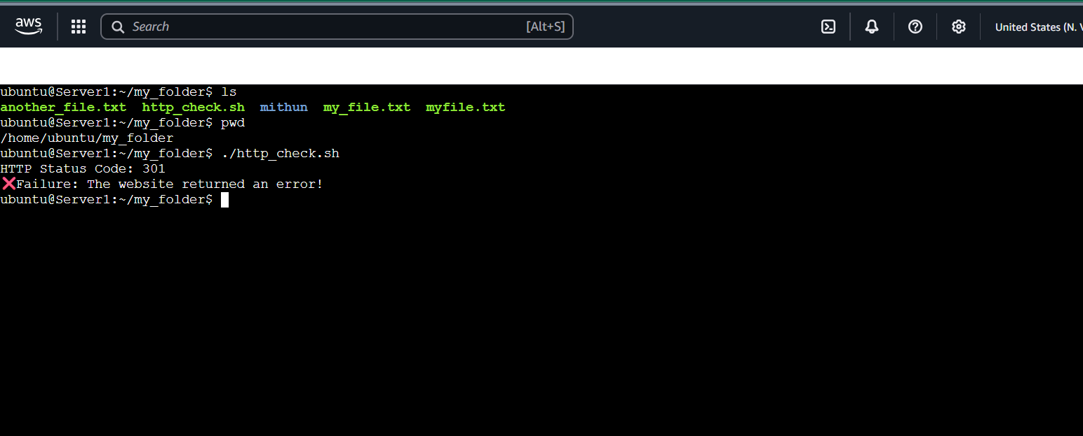
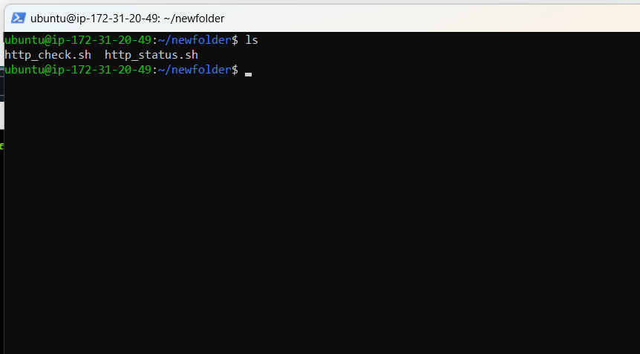
Created the script in the VI editor
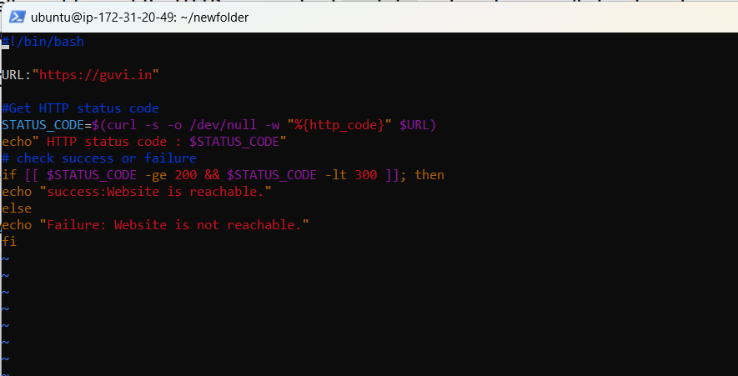
And made the script executable
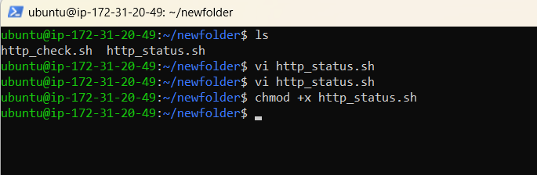
Executed the script and got the result website is not reachable.
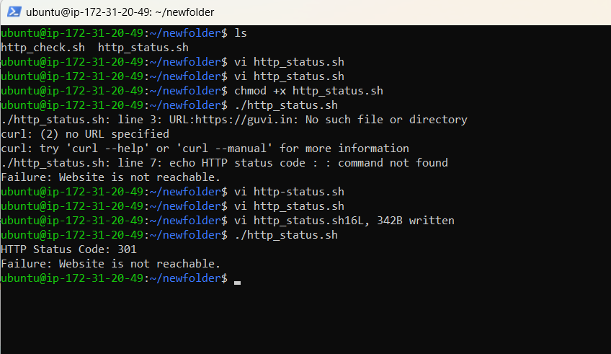

- Given a file, replace all occurrence of the word "give" with "learning" from 5th line till the end in only those lines that contain the word "welcome"
Example file content
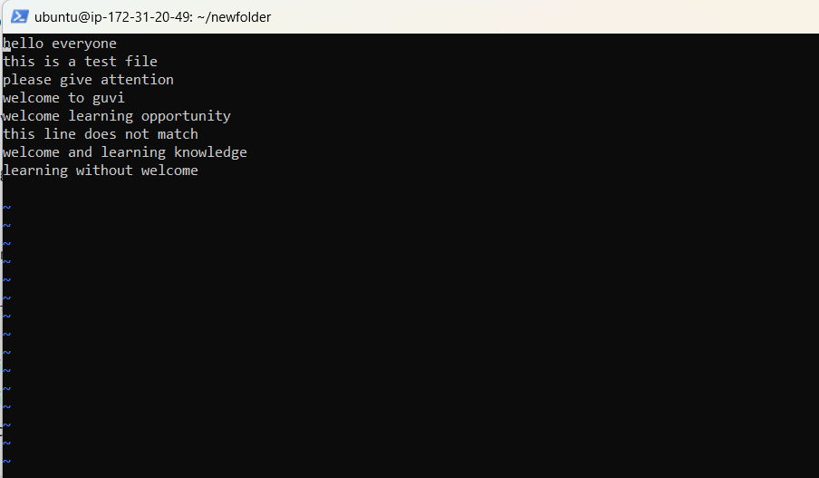
Output After Replacement
